Donkey Kong Country (1994, Super Nintendo), Rare. GAMEPLAY MODE

1. Composition
Tangible space | Full screen
Intangible space | Banana count is layered over tangible space
Negative Space | None
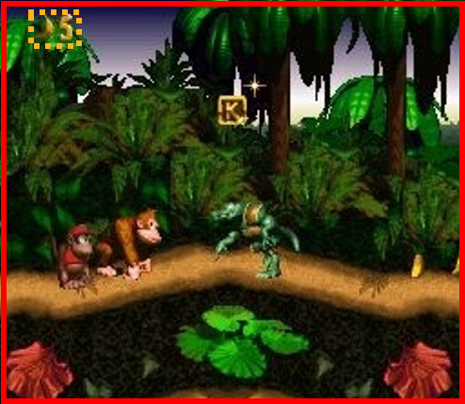
External | Zero-Ergodic
2. Ocularization

3. Framing mechanisms | Anchor : Subjective | Mobility : Connected

4. Plane Analysis
 | Agents | In-game | Off-game
Graphical materials | Pre-rendered 3D | Pre-rendered 3D | Pre-rendered 3D / Raster
Projection method | Orthogonal | Orthogonal | Orthogonal
Angle of projection | Horizontal | Horizontal | Horizontal

Notes:
Although it is a decently atmospheric and colorful case for 3D polygons as the future visual direction of the industry at the time, DKC operates as a classic platformer.
As the player navigates in a relatively uniform and flat (both mimetically and ergodically) space, the eye tends to keep busy with the horizontal line and the range of jumping opportunities. Of course, fast scrolling parallax constructions can hide some navigable treasure troves that are a bit harder to notice (as in this picture). The counter intuitive pleasure of platformers, it seems to me, is that we desire to navigate those spaces in which we don’t immediately believe or tend to expect anything from.
